Group Assignment Report – GlobalAid

Rafi Rahman, Ashwin Mayilvahanan, Matej Mitrev, Abuzar Lone

# Dataflow Diagram

## Top Level DFD

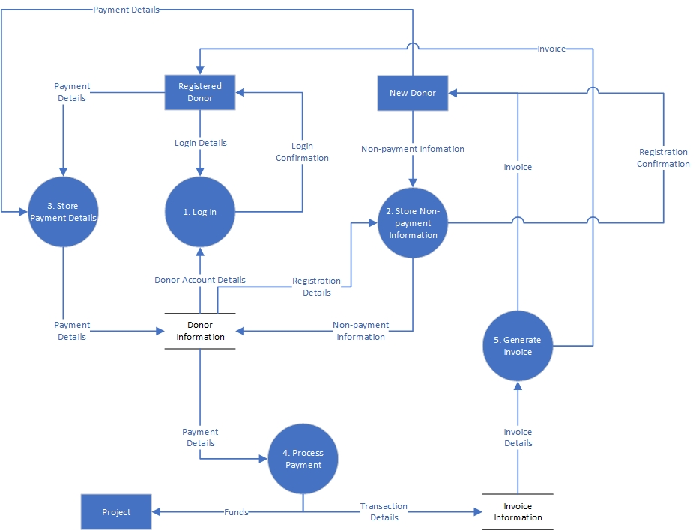

## Bottom Level DFD

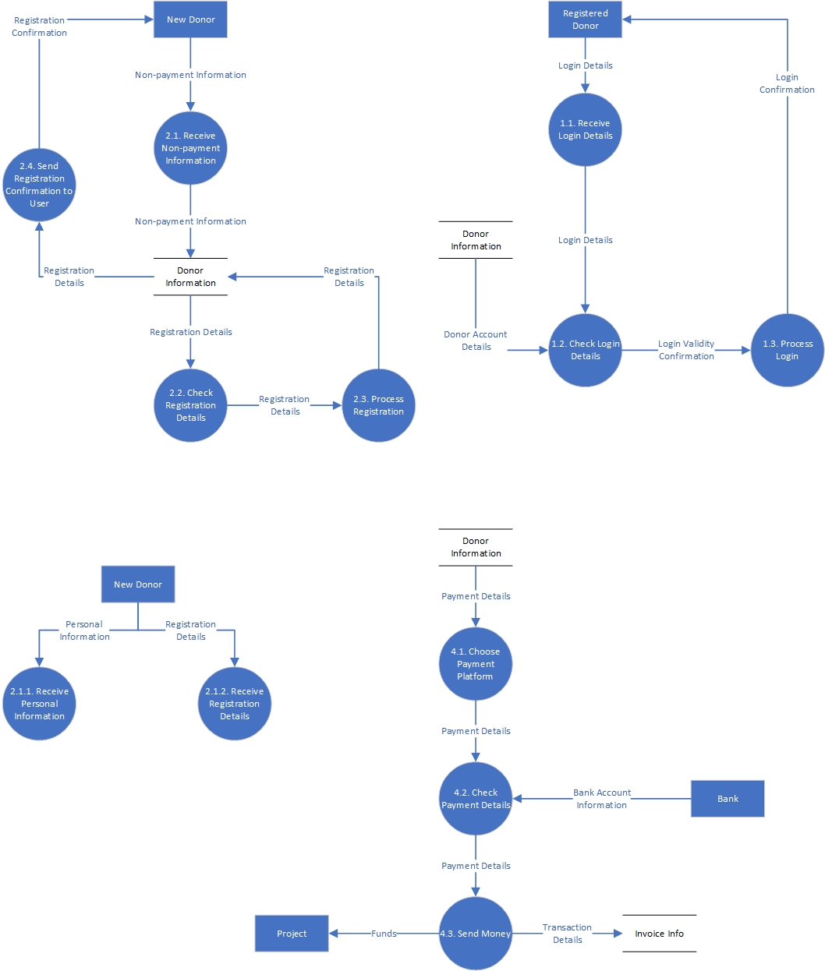

# Data Dictionary

**Address** = Address Number + (Sub-Premise) + Street Name + Suburb + City/Town + (Sub Administrative Area) + Administrative Area + Post Code + Country

**Personal Information** = Donor Title + First Name + Last Name + Email + Phone Number + **Address**

**Registration Details** = Register + Username + Password

**Login Details** = Username + Password

**Donor Account Details** = **Personal Information** + **Login Details**

**Non-payment Information** = **Personal Information** + **Registration Information**

**Card Payment** = Card Holder Name + Card Number + Date of Expiration + CVV

**Direct Debit** = BSB + Account Number + Account Name

**Donation Details** = Donation Amount + Merchant Fee + Administrative Fee + Pay Optional Fees + Program Choice + Region Choice + One-off + Monthly + Yearly

**Payment Details** = Card + [**Card Payment** | **Direct Debit**] + **Donation Details** + Payment Successful

**Invoice Details = Personal Information + Payment Details**

Address Data Table

|  |  |  |  |  |
| --- | --- | --- | --- | --- |
| Data Element | Description | Data Type | Length/Format | Example Data |
| Sub-Premise | Specific identifier for townhouses and apartments | String | 20 characters | B (23-B), 2 (102-2), Building 1 |
| Address Number | Numeric identifier of donor’s residence | Short | 5 characters | 23 102 |
| Street Name | Donor’s street name and street type | String | 50 characters | Kirinari St. Fifth Avenue (Manhattan, US) |
| Suburb | City district | String | 50 characters | Bruce |
| City/Town | City or town donor is from | String | 50 characters | Canberra London |
| Sub Administrative Area | Donor’s county, or district | String | 50 characters | Cheshire (England) San Diego County (US) |
| Administrative Area | Donor’s state, province, or region | String | 50 characters | NSW Australian Capital Territory |
| Postal Code | Donor’s postal code or ZIP code | String | 10 characters | 2601 (Australia) M3B 3S2 (Canada) |
| Country | Nation where donor resides | String | 50 characters | Australia  England |

Personal Information Data Table

|  |  |  |  |  |
| --- | --- | --- | --- | --- |
| Data Element | Description | Data Type | Length/Format | Example Data |
| Title | Form of addressing donor | String | 10 Characters | Mr. Mrs. |
| First Name | Person’s given name | String | 50 Characters | Bob Shalissa |
| Last Name | Person’s surname | String | 50 Characters | Jones Smith |
| Email | Unique identifier for an email account | String | 320 Characters | johnsmith@gmail.com |
| Phone Number | Phone number including country and area code | String | +###-###-###-#### | +498-963-648-0181 |
| Address | Where donor is currently living | Address Data Table | See Address Data Table | See Address Data Table |

Registration Details Data Table

|  |  |  |  |  |
| --- | --- | --- | --- | --- |
| Data Element | Description | Data Type | Length/Format | Example Data |
| Register | The user can choose to register or not | Boolean | Boolean values | TRUE  FALSE |
| Username | Identification used for donors | String | 20 characters | JohnSmith13 |
| Password | String of characters required to access system | String | 50 characters | Password123 |

Login Details Data Table

|  |  |  |  |  |
| --- | --- | --- | --- | --- |
| Data Element | Description | Data Type | Length/Format | Example Data |
| Username | Identification used for donors | String | 20 characters | JohnSmith13 |
| Password | String of characters required to access system | String | 50 characters | Password123 |

Card Payment Data Table

|  |  |  |  |  |
| --- | --- | --- | --- | --- |
| Data Element | Description | Data Type | Length/Format | Example Data |
| Card Holder Name | Who owns the card | String | 110 digits | Mr John Smith |
| Card Number | Number that identified card owners account | Long | 12-19 digits | 5555123456789000 |
| Date of Expiration | When card expires | Date | MM/YY | 12/20 |
| CVV | Card’s security code | Short | 3 digits | 123 |

Direct Debit Data Table

|  |  |  |  |  |
| --- | --- | --- | --- | --- |
| Data Element | Description | Data Type | Length/Format | Example Data |
| BSB | Is a six-digit number that is used to identify bank and branch | Integer | 6 digits | 033088 |
| Account Number | Code which identifies the bank account | Integer | 8 digits | 12345678 |
| Account Name | Name of the person who owns the bank account | String | 110 characters | Mr John Smith |

Donation Details Data Table

|  |  |  |  |  |
| --- | --- | --- | --- | --- |
| Data Element | Description | Data Type | Length/Format | Example Data |
| Donation Amount | Donor can choose from pre-set amounts or a custom amount | Currency | $10#.## | $100.00  $75.25 |
| Merchant Fee | A required processing fee from the card company | Currency | $10#.## | $5.00  $0.50 |
| Administrative Fee | A fee that covers admin costs | Currency | $10#.## | $5.00  $0.50 |
| Pay Optional Fees | User can choose to pay optional fees | Boolean | Boolean values | TRUE  FALSE |
| Program Choice | The donor can choose from a list of programs to pledge | String | 30 characters | Emergency Relief  Orphan Aid |
| Region Choice | The donor can choose from a list of regions to where the program donation will go to | String | 30 characters | Syria  Ethiopia  Fiji |
| One-off | The donor can choose if their donation is one-off | Boolean | Boolean values | TRUE  FALSE |
| Monthly | The donor can choose if their donation will recur monthly | Boolean | Boolean values | TRUE  FALSE |
| Yearly | The donor can choose if their donation will recur yearly | Boolean | Boolean values | TRUE  FALSE |

Payment Details Data Table

|  |  |  |  |  |
| --- | --- | --- | --- | --- |
| Data Element | Description | Data Type | Length/Format | Example Data |
| Card | Donor can pay with card and if not, direct debit | Boolean | Boolean values | TRUE  FALSE |
| Card Payment | Payment with card | Card Payment Data Table | See Card Payment Data Table | See Card Payment Data Table |
| Direct Debit | Payment with direct debit | Direct Debit Data Table | See Direct Debit Data Table | See Direct Debit Data Table |
| Donation Details | The donation information from the donor | Donation Details Data Table | See Donation Details Data Table | See Donation Details Data Table |
| Payment Successful | The payment was successful or it wasn’t | Boolean | Boolean values | TRUE  FALSE |

# Process Specification

1.2. Check Login Details

GET Login Details FROM Receive Login Details

GET Donor Account Details FROM Donor Information

IF Login Details !match (GET Login Details FROM Donor Account Details)

THEN Login Validity Confirmation = TRUE

ELSE Login Validity Confirmation = FALSE

2.4. Send Registration Confirmation to User  
GET Registration Details FROM Donor Information

GET Register FROM Registration Details

IF Register = TRUE

THEN Registration Confirmation = PRINT(You have registered successfully.)

ELSE Registration Confirmation = PRINT(You will be donating anonymously.)

4.1. Choose Payment Platform

GET Payment Details FROM Donor Information

GET Card FROM Payment Details

IF Card = TRUE

THEN Card Payment

ELSE Direct Debit

4.2. Check Payment Details

GET Bank Account Information FROM Bank

IF Payment Details !match Bank Account Information

THEN GET Funds FROM Bank Account Information

GET Donation Details FROM Payment Details

GET Donation Amount FROM Donation Details

IF Funds > Donation Amount

THEN Payment Successful = TRUE

ELSE Payment Successful = FALSE

ELSE Payment Successful = FALSE